Algebra 1: Unit 8, Lesson 1

- The graph of the quadratic function $y=x^{2}+6x+8$ is shown.
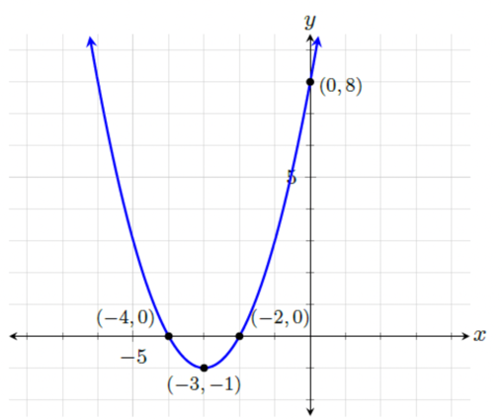
Where does the graph of the function cross the $x$-axis?
$(-4,0)$ and $(-2,0)$

- The graph of the quadratic function $y=x^{2}+8x+15$ is shown.
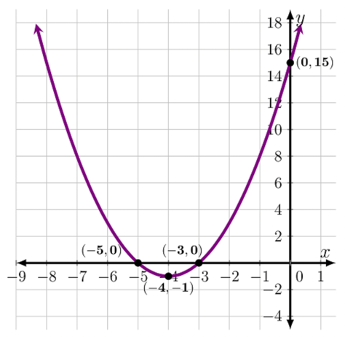
What point(s) does the graph of the function change from decreasing to increasing?
$(-4,-1)$

- An equation of a quadratic function is shown.
$$y=4(x+1)(x+2)$$
What is the $y$-intercept?
$(0,8)$

